Building Mobile App

1.Configure the application to receive the data from cloud

| Date | 17 November 2022 |
| --- | --- |
| Team ID | PNT2022TMID26825 |
| Project Name | project-Real Time River Water Quality Monitoring And Control System |
| Maximum Marks | 4 Mks |

Mobile App:

This is created through the use of gateway nodes to create a Virtual Data Warehouse. This Virtual Data Warehouse allows application developers to map access to remote data points. This software-defined gateway is run adjacent to the application it serves and can be deployed within a cloud environment or in a data center.

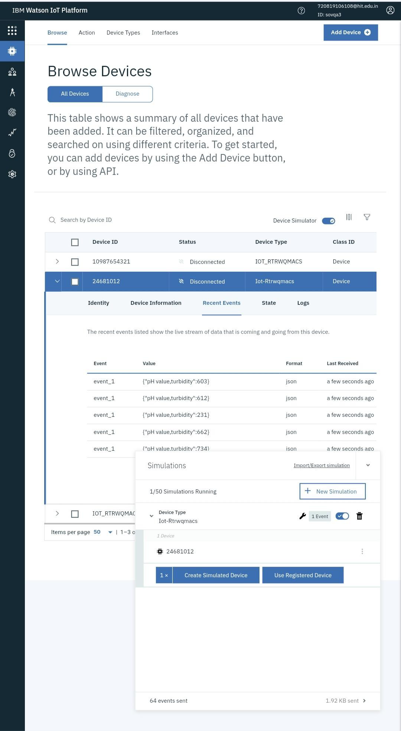

This Virtual Data Warehouse allows for the virtual aggregation of data so that an application (or many applications) can easily consume it. Once a data source is added to the Virtual Data Warehouse an application has secure, real-time, persistent access to that data set.

Hardware device – The hardware device is one of the easiest methods of deployment because Trust grid handles all of the software imaging, logistics and deployment support for the end-user. A hardware appliance is ideal for environments with limited onsite support.

